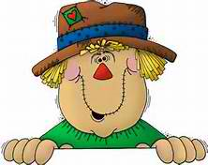
Annual
Duran’s Down Home Days
Saturday, May 19 & Sunday, May 20, 2018
Waterford Community Fairgrounds

HOLD HARMLESS AGREEMENT
Please read and sign.

Hold Harmless Agreement: Person(s) agree to hold harmless, Duran’s Down Home Days/Duran’s Farm Fresh Products and its owners, agents and employees; the Waterford Community Fairgrounds and its owners, agents and employees; and Make-A-Wish® Greater Pennsylvania and West Virginia and its owners, agents and employees responsible from suits, claims, damages, personal injuries and loss or damaged property sustained during the period of set up, execution, and tear down of this event. Participants agree to hold harmless, defend and indemnify Duran’s Down Home Days/Duran’s Farm Fresh Products and its owners, agents and employees from any suits, claims, damages, personal injuries, losses and damaged property arising from the negligence, recklessness, or intentional conduct of participants or participants’ owners, agents and employees.

Signature: __________________________________________ Date: ____________________

Signature: __________________________________________ Date: ____________________
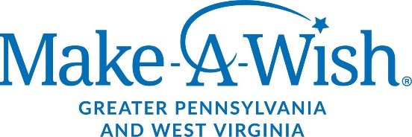
EVENT BENEFITS

